St10310392 cldv ice task one

My blob storage of my photos that I use on my home page as a carasol

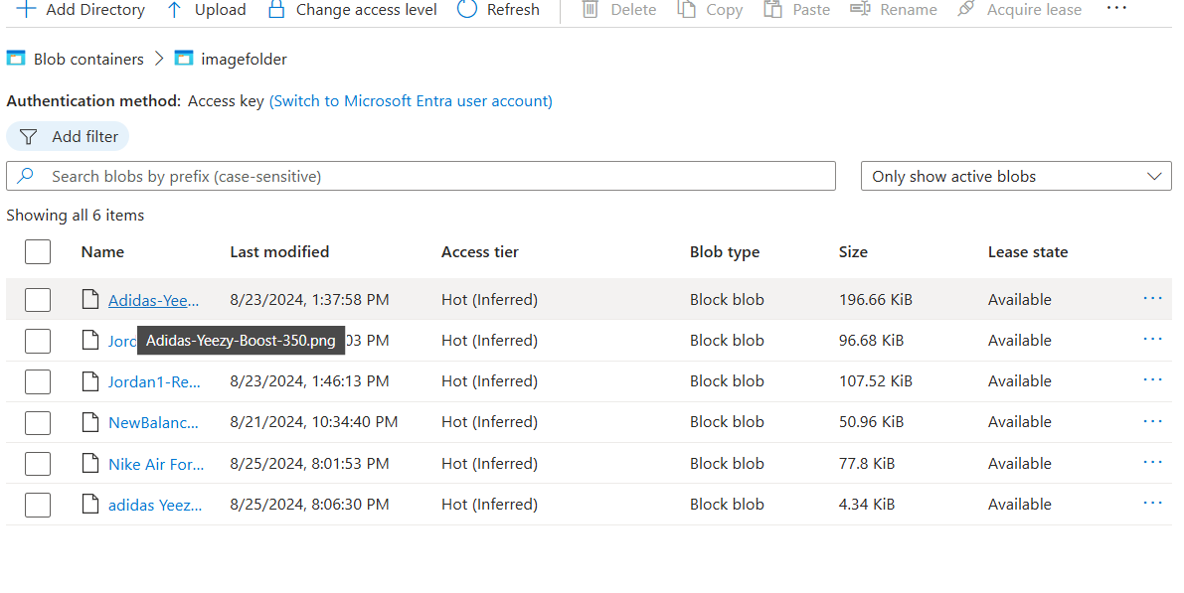

This is my home page, the photos automatically cycle through the blob storage to display this

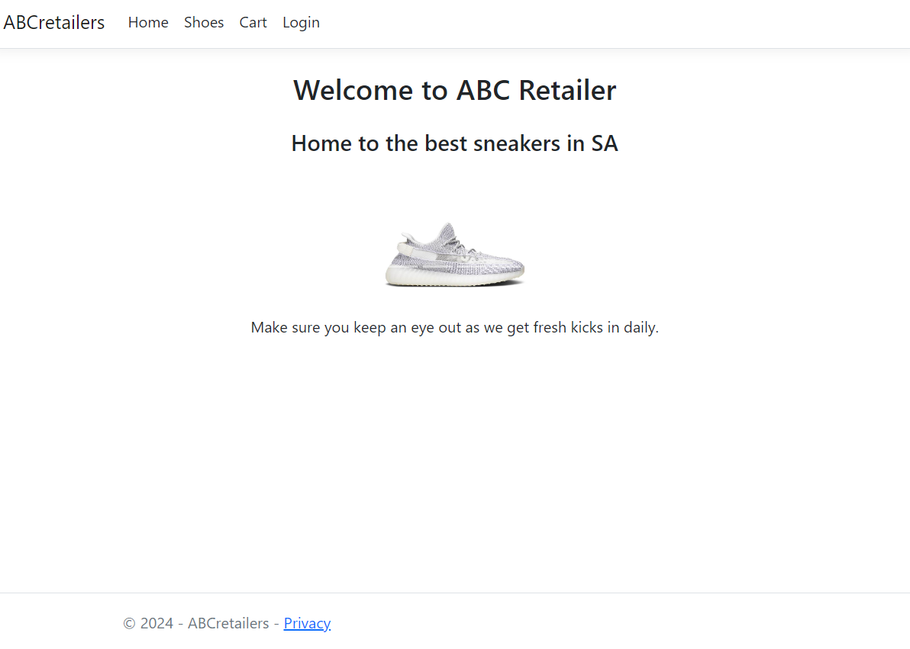

This is my table storage of different shoes as well as calling the blob images

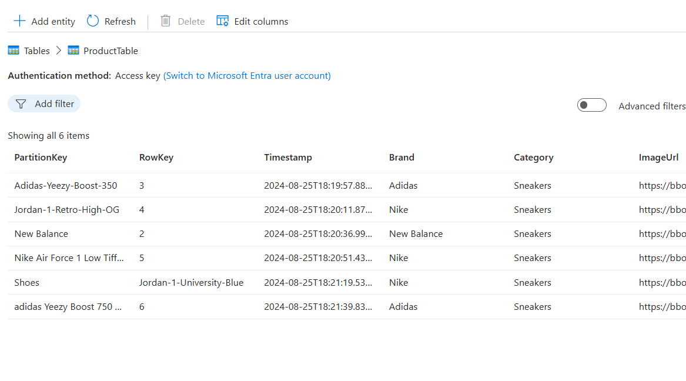

This Is what it looks like when view the table you are also able to filter by brand

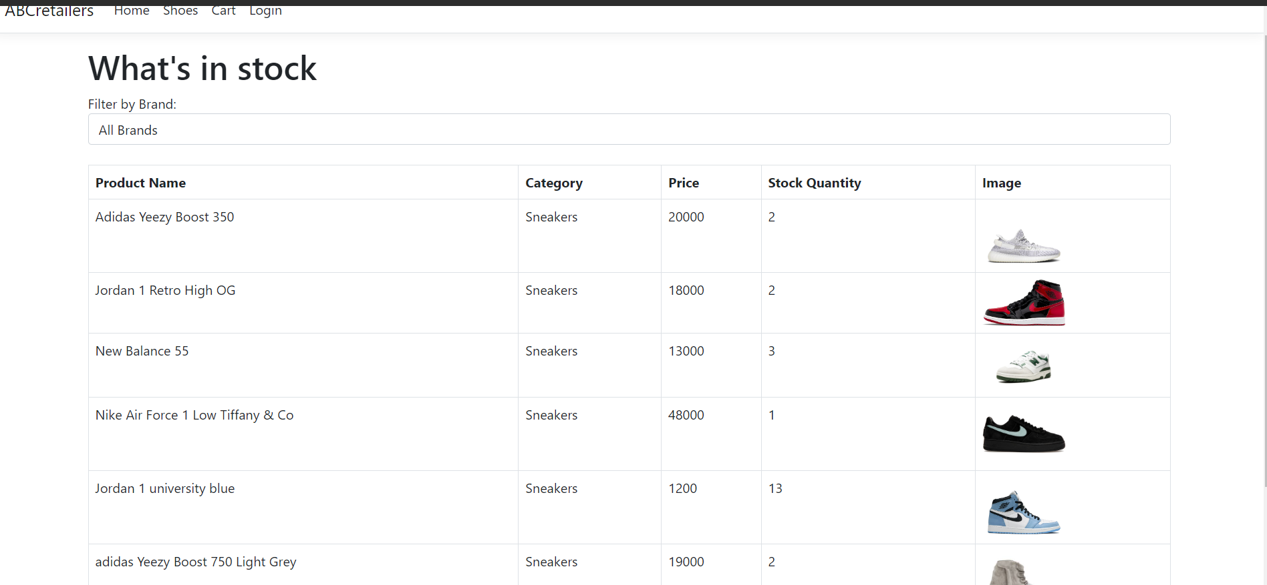

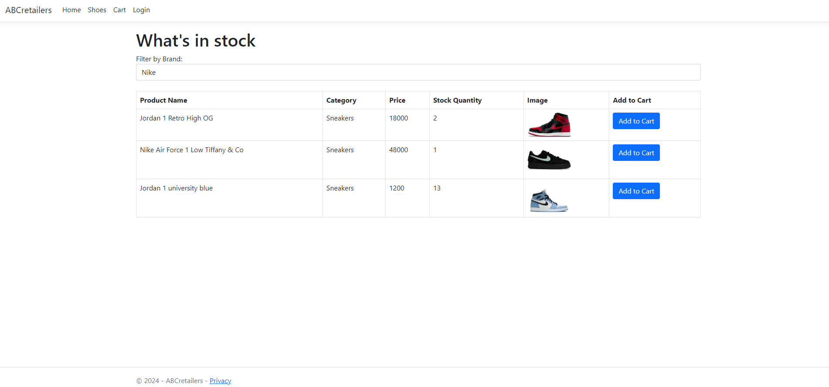

j

But if the user decides to go purchase these three shoes by clicking on the Add to Cart button.

They will be taken back to the cart page and will see the items they have selected

And if we look in our cart table in azure we will see the three items the user has added

But if the user decides they only want to get the Air Forces and delete the other two

There cart page will be updated only showing the item they are looking for.

As well the Cart table will be Updated in Azure.

References

(No date) *Pinterest*. Available at: https://za.pinterest.com/ (Accessed: 30 August 2024).

*Buy Adidas Yeezy 750 Light Grey Glow In The Dark Online in Australia* (2024) *Kickstw*. Available at: https://kickstw.com.au/product/adidasyeezy750lightgreyglowinthedark/ (Accessed: 30 August 2024).

H.M.MubashirH.M.Mubashir                      24011 silver badge1717 bronze badges and RegesteaRegestea                      67011 gold badge1010 silver badges3434 bronze badges (1967) *I am creating an ASP.NET Core 5.0 MVC project. I want to filter the list of products when check the checkBox of Men the than show only men products*, *Stack Overflow*. Available at: https://stackoverflow.com/questions/69345668/i-am-creating-an-asp-net-core-5-0-mvc-project-i-want-to-filter-the-list-of-prod (Accessed: 25 August 2024).

Mark Otto, J. T. (no date) *Carousel*, *· Bootstrap*. Available at: https://getbootstrap.com/docs/4.1/components/carousel/ (Accessed: 27 August 2024).

*New Balance 550 White Green BB550WT1 (Size 5, 9.5, 10, 12) SHIPS TODAY* (no date) *eBay*. Available at: https://www.ebay.ca/itm/234949902459 (Accessed: 30 August 2024).

*Nike Air Force 1 Low (M) Tiffany & Co. 1837* (no date) *The Valley Store Ph*. Available at: https://thevalley-store.ph/products/nikeairforce1lowm-tiffanyandco (Accessed: 30 August 2024).

*W3Schools.com* (no date) *HTML video autoplay Attribute*. Available at: https://www.w3schools.com/tags/att_video_autoplay.asp (Accessed: 26 August 2024).

Yadav, P. (no date) *Understand Antiforgery Token In ASP.NET MVC*, *C# Corner*. Available at: https://www.c-sharpcorner.com/article/understand-antiforgeri-token-in-asp-net-mvc/ (Accessed: 26 August 2024).